1 a Bit Stuffing

#include<stdio.h>

#include<string.h>

#include<stdlib.h>

void sender();

void receiver(int \*message,int l2);

int main(void)

{

sender();

}

void sender()

{

int i,j,n,count=0,zerocounter=0,zero=0;

int msg[50];

int result[50];

printf("Enter the number of bits of the message\n");

scanf("%d",&n);

printf("Enter the bits\n");

for(i=0;i<n;i++)

{

scanf("%d",&msg[i]);

}

result[0]=0;

result[1]=1;

result[2]=1;

result[3]=1;

result[4]=1;

result[5]=1;

result[6]=1;

result[7]=0;

j=8;

for(i=0;i<n;i++)

{

if(msg[i]==0)

{

result[j]=msg[i];

j++;

zero=1;

count=0;

}

else

{

if((count==5)&&(zero==1))

{

result[j]=0;

zerocounter++;

j++;

result[j]=msg[i];

j++;

count=0;

}

else

{

result[j]=msg[i];

j++;

count++;

}

}

}

result[j++]=0;

result[j++]=1;

result[j++]=1;

result[j++]=1;

result[j++]=1;

result[j++]=1;

result[j++]=1;

result[j++]=0;

int l1=16+n+zerocounter;

printf("The length is: %d\n",l1);

printf("The frame is\n");

for(i=0;i<j;i++)

{

printf("%d",result[i]);

}

receiver(result,l1);

}

void receiver(int \*result,int l2)

{

int i,j,counter,l3;

int mesg[100];

l3=l2-8;

j=0;

for(i=8;i<l3;i++)

{

if(result[i]==0)

{

if(counter==5)

{

i++;

mesg[j]=result[i];

j++;

counter=0;

}

else

{

mesg[j]=result[i];

j++;

counter=0;

}

}

else

{

mesg[j]=result[i];

j++;

counter++;

}

}

printf("\nReciever side message is:");

for(i=0;i<j;i++)

{

printf("%d",mesg[i]);

}

}

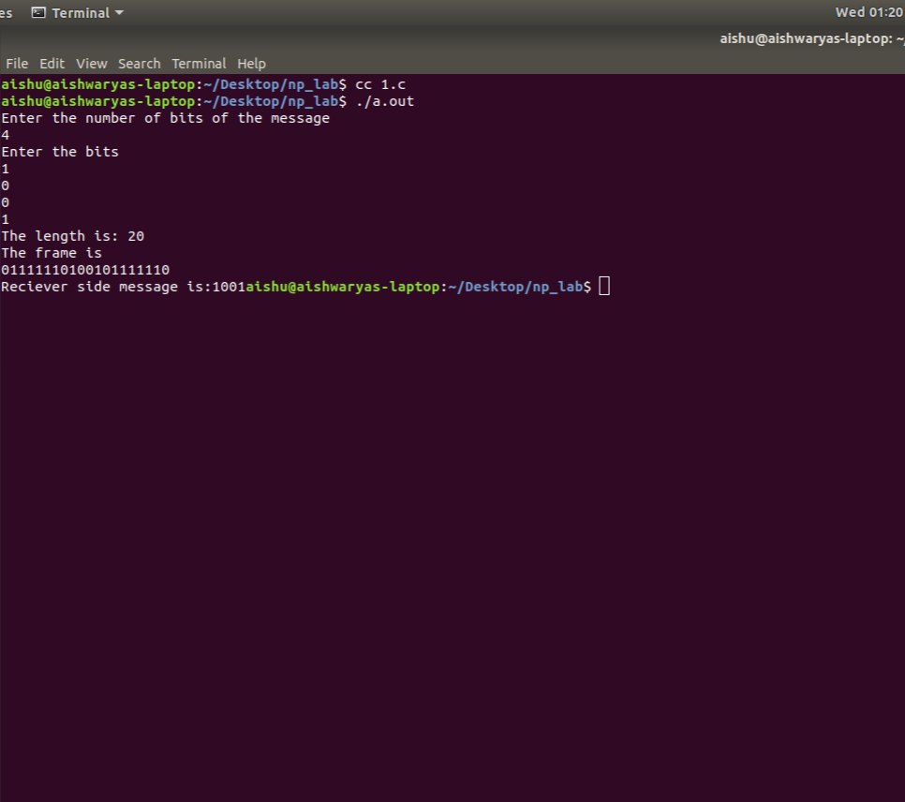

1 b Byte Stuffing

#include<stdio.h>

#include<string.h>

void reciever();

char frames[1024];

int main()

{

int n,len,i;

char buffer[256],length[10];

printf("How many frames you want to send: ");

bzero(buffer,256);

scanf("%d",&n);

for(i=0;i<n;i++)

{

printf("Enter frame\n");

scanf("%s",buffer);

printf("String length of buffer is %d\n",strlen(buffer));

len=strlen(buffer);

len=len+1;

sprintf(length,"%d",len);

strcat(frames,length);

strcat(frames,buffer);

}

for(i=0;frames[i]!='\0';i++)

printf("%c",frames[i]);

reciever();

return 0;

}

void reciever()

{

int i=0,framelen,lpvar;

char leninchar;

printf("\n\nThis is the reciever\n");

printf("\nData recieved is %s",frames);

while(frames[i]!='\0')

{

leninchar=frames[i];

framelen=(int)leninchar-(int)'0';

printf("\nLength of this frame is %d\n",framelen);

printf("\nFrame ----->");

lpvar=i+framelen;

i=i+1;

while(i<lpvar)

{

printf("%c",frames[i++]);

}

printf("\n");

}

}

